**Aim:**

To create a snapshot of a Virtual Machine (VM) and test it by restoring to the previous version/cloned VM using VirtualBox.

**Procedure:**

**1.** **Open VirtualBox:**

* Launch VirtualBox on the host system.
* Select the Virtual Machine for which the snapshot is to be created.

**2. Create a Snapshot:**

* With the VM powered off or running, go to the **Machine → Take Snapshot** option.
* Provide a name and description for the snapshot.
* VirtualBox saves the current state of the VM (including CPU, memory, disk state).

**3. Modify the VM State (for testing):**

* Start the VM and make changes (install new software, change settings, etc.).
* Shut down the VM after making changes.

**4. Restore to Previous Snapshot:**

* Select the VM → Go to **Snapshots** tab.
* Choose the previously created snapshot and click **Restore**.
* The VM reverts back to the exact state when the snapshot was taken.

**5.** **Verify Snapshot/Clone:**

* Start the restored or cloned VM.
* Confirm that the system has reverted to the saved state (before modifications).

**OUTPUT: (Modified VM State)**

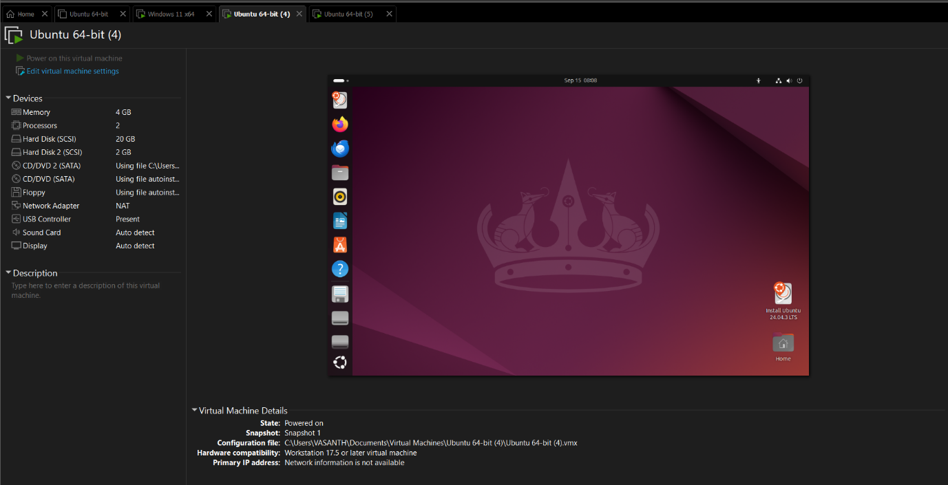

**OUTPUT:** (**Restored to Previous Snapshot)**

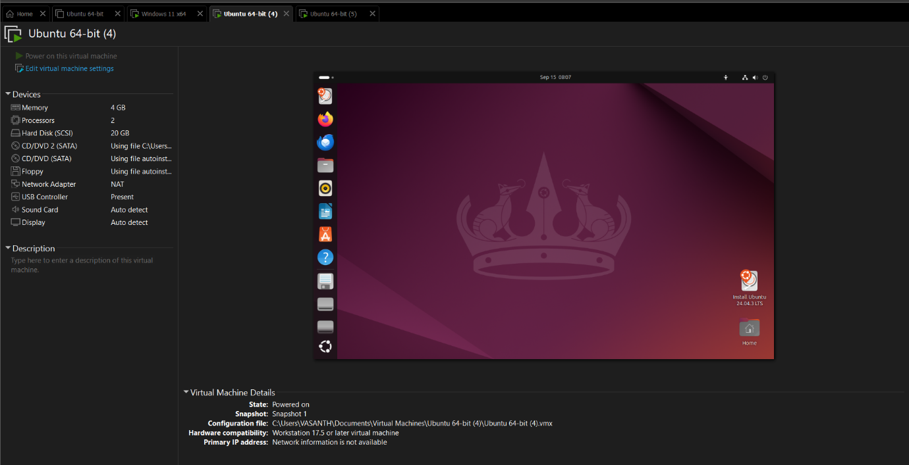

**Result:**

A snapshot of the Virtual Machine was successfully created and tested by restoring the VM to its previous state. A cloned VM was also created and verified using VirtualBox.